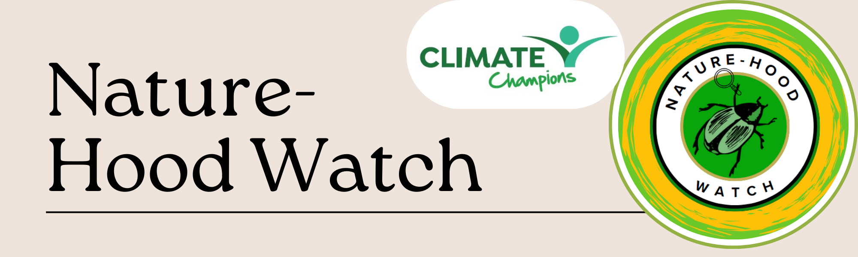
What is the Nature-Hood Watch?
It is a collection of private spaces, such as window boxes, gardens and balconies, that are changed to benefit nature. It means that rather than one space being dedicated to nature, we create a series of smaller spaces across North Paddington that will allow the natural world to flourish, as well as helping improve air quality, increase spaces and access to nature in the area, help with wellbeing and mental health. Part of the project is also about increasing education and knowledge. Participants will have the opportunity to attend science lessons for adults, learn about gardening and biodiversity, help partake in citizen science projects in the area, and enter for awards!
How can I get involved?
At home
- You can apply for a starter kit through contacting Lola with on 07762825271 or lola@pdt.org.uk
- Alternatively, you can begin in whatever way feels right to you – if you have a garden, you can leave a few square meters to be rewilded, or you can cut a hole in your fence to allow for safe passage for hedgehogs. If you’re have an unloved bit of land outside your building, you can begin to tend it (making sure you find out who the landowner is first of course!). If you want to share your skills with other people, talk to your neighbours, spread the word, or contact Lola to see how your knowledge can best be shared.
- In order to confirm a home/garden/piece of land as being part of the nature reserve, everyone will be provided with a sticker to identify it, which will be placed in their window to ensure we can create a network of participants, and spread the sense of community.
Nature of Things education
- You can come to our ‘Nature of Things’ events, held on the last Thursday of the month from 7 - 9pm, at Mason and Fifth, Woodfield Road. Childcare always provided.
  - Step into an evening of ideas, questions, and kinship. Nature of Things is a monthly open lecture series designed to unpick the environmental issues shaping our lives — without jargon, gatekeeping, or PowerPoint fatigue.
Each session invites a brilliant guest (think scientists, urban ecologists, nature writers, or local trailblazers) to speak for no more than 30 minutes, sparking a conversation that continues among all who gather. No prior knowledge required, just curiosity, open minds, and a willingness to listen — or challenge.
Hosted in the Mason & Fifth community space, these salons are free and welcoming to all. Whether you're a seasoned activist, a quiet observer, or just someone who wonders why sparrows have vanished from your street, this is a space for you.
This series is part of the Nature-Hood Watch initiative, turning our urban patch into something greener, wilder, and more connected.
What does it cost?
It is completely free to get involved! We will provide the initial set up kits, such as pollinator friendly flowers, bug hotel making instructions, bird feed etc if needed, and we will give everyone a vinyl sticker to place in their windows to show they’re part of the project. Contact Lola on 07762825271 or lola@pdt.org.uk to receive the sticker to place in your window

Where is it happening?
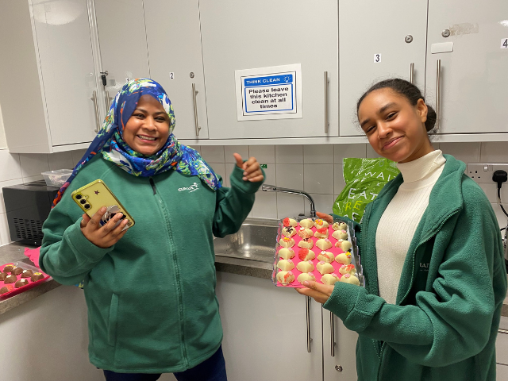  QUEEN’S PARK | 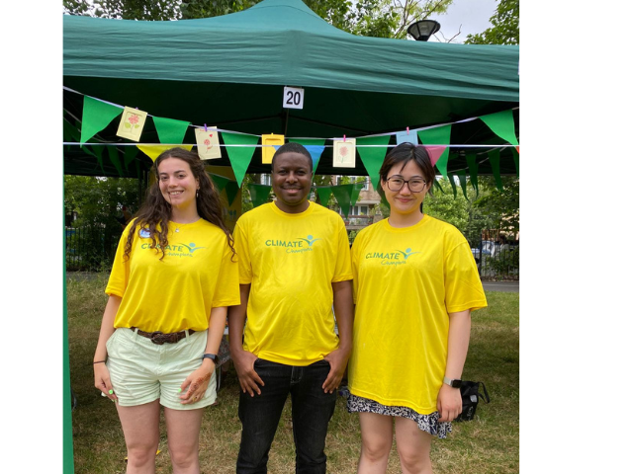  HARROW ROAD | 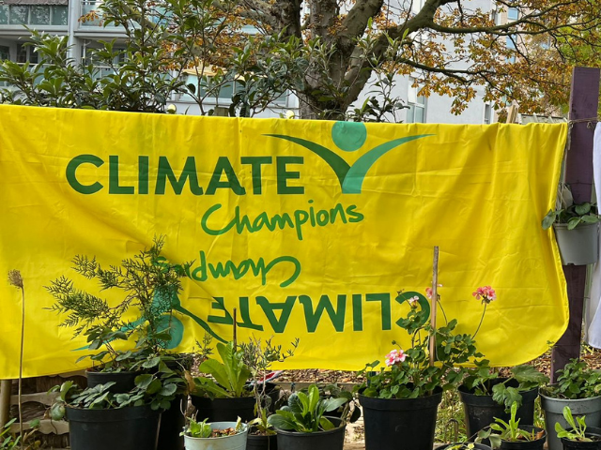  WESTBOURNE

Can I get involved if I don’t know about plants and nature?
Absolutely! Part of the goal is to encourage people to learn more and get involved in new things. We will have regular education sessions, online content, and hope to build a community network where you can learn from neighbours. You can see the end of this guide for a flow chart to help you start off your journey .
What is community science?
The process of getting local residents to engage with and notice the environment around them, through becoming citizen scientists! For example, on their walk to the tube station, they can take note each day of the butterflies they see. By uploading these to our iNaturalist site, we can record the number and amount of species in the area, and see if the nature reserve improves the amount of biodiversity. You can join the North Paddington Nature-Hood Watch iNaturalist by following this link https://www.inaturalist.org/projects/north-paddington or by downloading it on the App store or Google Play.
Caring for nature improves wellbeing, supports wildlife, and makes our streets cooler, cleaner and more resilient to environmental challenges.
Scan this code to join the iNaturalist site

Scan this code to join the Green North Paddington WhatsApp group


Greener Living
Make green spaces part of daily life | Spending conscious time in nature can improve your mental and physical wellbeing  - Walk or exercise in local parks for fresh air and to relax, whilst mindfully noticing nature around you  - Join a community gardening initiative to meet your neighbours, support biodiversity and grow your own food  - Create green spaces at home – even small balconies or windowsills can support nature and make you feel happier at home. You could plant species that attract pollinators, like bees or grow your own herbs and salad greens
Welcome wildlife into your area | Providing a space to protect and enhance nature and biodiversity makes our neighbourhoods healthier and more resilient  - Plant native wildflowers and draught resistant plants like cosmos, sunflowers, and foxgloves to encourage pollinators to an area, even during periods of dry weather and heatwaves  - Attract birds by putting our food and fresh water on a bird table and installing nesting boxes in safe spots  - Think about how you can integrate micro-habitats into your garden with log and rock piles for invertebrates, or nesting boxes for birds to be encouraged to an area whilst maintaining and planting hedges increases habitats used by small mammals
Garden sustainably and save water | Simple changes in how you garden can help conserve water, enrich soil, and support local wildlife  - Make your own compost from autumn leaves and food scraps  - Use grass clippings as mulch to supress weeds and improve soil, whilst retaining moisture  - Install a water butt or use greywater to collect rainwater for watering your garden  - Avoid using sprinklers – instead, water plants deeply and less frequently to encourage stronger roots  - Let your grass grow longer throughout summer – it will stay greener  - Choose draught-tolerant plants
Care for nature and keep spaces clean | Keeping outdoor spaces clean and reducing pollution can help protect nature and make communities healthier  - Take litter home or use bins to keep public spaces clean  - Join local clean-up events  - Reduce water and chemical use to protect the canal and soil

Advice for gardens
- Plant native wildflowers and draught resistant plants like cosmos, sunflowers, and foxgloves to encourage pollinators to an area, even during periods of dry weather and heatwaves
- Attract birds by putting our food and fresh water on a bird table and installing nesting boxes in safe spots
- Think about how you can integrate micro-habitats into your garden with log and rock piles for invertebrates, or nesting boxes for birds to be encouraged to an area whilst maintaining and planting hedges increases habitats used by small mammals
- Let nature take its course, even in a small way! You don’t need to turn your whole garden into a forest, but if you leave a small corner to grow wild, de-pave one paving stone, or if you have a lawn moving it less, then you will help wildlife to thrive! You can also help this process by choosing to plant native wildflowers, which are pretty and provide nectar for bees and butterflies, or even sometimes birds and bats!
- Try to avoid using chemicals on your garden, and leave some weeds. They offer food, shelter and breeding grounds for insects, that then mean there is more food for birds and hedgehogs. You can plant things that will repel pests.
- Look on the Royal Horticultural Society’s website to find what plant is right for your garden space/pest problems!
- https://www.rhs.org.uk/advice
- If you have space, you can plant trees and shrubs. These will also help to reduce noise and flooding, as well as improving air quality!
- Make a pond! This is amazing for insects and amphibians, and general biodiversity of your garden. If you can’t dig a pond, you can make a simple small one! You could easily dig a hole and put a washing up bowl in it, and surround it with plants. Make sure to have a ramp on at least one side so the wildlife doesn’t get trapped.
- Use soil without peat! The world’s peatlands have about twice as much CO2 stored as all the forests combined, so using peat free soil helps to keep carbon in the ground
- Install a water but (or just a large bucket!) to catch rainwater. This will help save water in times of drought

Advice for balconies
- - You can make your own bug hotel, bird box or bird feeder to help give wildlife an extra boost
- Offer a water source for birds and insects! It can be just a bowl that you refresh with water, but make sure to have a ramp on at least one side so animals don’t get trapped
- If possible, surround the water source with plants so wildlife has safe cover to approach it, and keep it topped up through the winter and summer months,
- Use a mixture of spaces, for example make a hanging basket! This allows you to have more diversity in what you grow, like trailing plants such as honeysuckle, or herbs / vegetables like tomatoes or chives, or just lovely flowers!
- Use soil without peat! The world’s peatlands have about twice as much CO2 stored as all the forests combined, so using peat free soil helps to keep carbon in the ground
- You can install a butterfly feeder easily, it needs a mixture of sugar and water to help butterflies refuel themselves.
- Install a sand bath so birds can clean themselves!
- Create a bird box, so birds can have shelter to raise their chicks
- Collect rainwater to use to water your plants. You can do this easily, with a stretched tarpaulin and a container! This helps save water
- Think vertically – can you install trellises or grow climbing plants, to make sure you have more greenery in the garden?
- You can make a small compostery, or a wormery in any space! Compost your kitchen scraps and coffee grounds, and use the soil created to add to your plants
- Use eco-friendly lighting on the balcony, like solar powered lights or ambient, LED string lights. Avoid using bright or harsh lights, as these disturb and deter nocturnal animals
Advice for window boxes
- Put out nuts and seeds to help wild birds. You can buy bird feeders and fill them up, or for a cheaper alternative method, you can take a 2-litre plastic bottle, and cut a large rectangle hole in it. Then fill up the bottom section with seeds and nuts, and tie a string to the neck of the bottle to hang it.
- Use your window boxes strategically – if you plant seeds that are food sources for native insects, you’ll be helping way more wildlife than you would with non-native species
- Make sure your window box fits your space! Bigger isn’t always better, use a tape measure to be sure that the window box fits
- Wood is the best option for a window box – it allows the roots inside to not be stifled
- Make sure to line your window boxes. You want them to have a few holes drilled in the bottom for drainage, and you could also add a layer of gravel or a layer of pebbles to make sure soil is kept in place during heavy rain. You could also line it with jute or coconut fibres, to protect the inside of the box, meaning it’s easier to clean out when you need to remove new flowers. You should cut holes in these liners too, to make sure water can drain through
- Try and grow a mix of things. You can mix seasonal plants with hardy year round plants
- Create a bird box, so birds can have shelter to raise their chicks
- Try and choose plants that are good for pollinators – for example herbs, like oregano or rosemary. Make sure you think about what way your window faces and how much sunshine it gets!
- Think vertically – can you install trellises or grow climbing plants?
- Use soil without peat! The world’s peatlands have about twice as much CO2 stored as all the forests combined, so using peat free soil helps to keep carbon in the ground
- Water your window box! The soil should be damp to the touch
Nature walking trail one - to the Natural History Museum!
What is the nature walking trail?
It is a walking route that links the green space in the area, so people can have a space to walk that is majority off-road, links spaces together, and shares information about nature, biodiversity, and culture. It will eventually be signposted and have a map, as well as spaces to stop on route.
1 – Beginning at Queen’s Park Gardens, walk across the lovely park, making sure to explore the wildlife area!
2 – At the end, turn down Fourth Avenue, until you pass Queen’s Park Library. Cross the road to reach the canal side, and stop to watch the redevelopment of the park there (although when you’re reading this it may be a real park!)
3 – Continue along to Half Penny Steps, and cross over the canal.
4 – Meander down the canal, enjoying looking at the geese, ducks and coots! You can also go through Meanwhile Gardens, which is right next to the canal side, and explore their gorgeous creations.
5 – Keep going down the canal until you reach Grand Junction and Westbourne Open Space. Here is a perfect place to stop for a coffee!
6 – Walk through Westbourne Open Space towards Royal Oak, and continue down Porchester Road. Look out for the plants put in place by Clean Air Bayswater next to the station!
7 – Cross over Porchester Gardens and reach Inverness Terrace. Go down here until you enter Kensington Gardens
8 – You could spend forever exploring here! Try and spot some highlights, like the Diana Memorial Playground, or find a tree that looks particularly gorgeous that day.
9 – Exit Hyde Park at Exhibition Road. This is one of the world’s most intelligent streets, with Imperial College, the Victoria and Albert Museum, the Science Museum, and the Natural History Museum all there!
10 – Enjoy your explore down Exhibition Road, and pop into any museums that catch your fancy
11 – End your walk in the Natural History Museum’s urban nature gardens. These are a testament to what you can do for nature in an urban environment. Try and listen to the trees talking to each other!

Walking trail two - to London Zoo!
1 – Beginning at Queen’s Park Gardens, walk across the lovely park, making sure to explore the wildlife area!
2 – At the end, turn down Fourth Avenue, until you pass Queen’s Park Library. Cross the road to reach the canal side, and stop to watch the redevelopment of the park there (although when you’re reading this it may be a real park!)
3 – Continue along to Half Penny Steps, and cross over the canal.
4 – Meander down the canal, enjoying looking at the geese, ducks and coots! You can also go through Meanwhile Gardens, which is right next to the canal side, and explore their gorgeous creations.
5 – Keep going down the canal until you reach Grand Junction and Westbourne Open Space. Here is a perfect place to stop for a coffee!
6 – Continue down Delamere terrace along the canal until you get to Westbourne Terrace Bridge. Cross over, and go down Blomfield Road until you get to Warwick Avenue Take a sharp right and go down Maida Avenue.
7 – Cross Edgware Road, and go up Aberdeen Place to the very end, where it meets Cunningham Place. Go down the little alleyway to rejoin the canal.
8 – Continue along Regent’s Canal Towpath, following the signs, along Lisson Grove.
9 – You should be able to stay on the towpath all the way into Regent’s Park! Use the Avenue Road bridge to come up into the park and go to the zoo, or continue along the path all the way to Camden.


Walking trail three – 6 miles around North Paddington!
Scan the code to follow this map around North Paddington, seeing 13 points of interest and (from 2026) collecting stamps for your own ‘Pilgrim Passport’!

This is a joint project with Westminster Libraries as part of the Europe Challenge, launching in 2026. Find out more about our ‘Nature Pilgrimage’ here:
https://theeuropechallenge.eu/north-paddington-nature-pilgrimage/

Things to join

- Join our Green North Paddington News WhatsApp group to get updates once a week about free or low cost events to do with nature and the environment in the local area! Scan this QR code, or follow this link:
https://chat.whatsapp.com/Bl5VefrIyl0HOsOuyGfBWr

- Join our iNaturalist project to help document what species live in the area! You can find it on the App Store or the Google Play Store. If you are new to identification, you can choose to download ‘Seek’, which is a version of iNaturalist designed to help people start becoming citizen scientists

- Join our monthly Nature of Things sessions at Mason and Fifth, on the last Thursday of each month, from 7 - 9pm, to debate, discuss, and learn. Each session invites a brilliant guest (think scientists, urban ecologists, nature writers, or local trailblazers) to speak for no more than 30 minutes, sparking a conversation that continues among all who gather. No prior knowledge required, just curiosity, open minds, and a willingness to listen — or challenge.

- Join the Climate Champions! Contact Lola on 07762825271 or lola@pdt.org.uk to learn more


